**Installation of Robot framework with executable files only in Windows**

**System Requirements:**

1) Windows 7 (32- bit) with admin access and Internet Access

2) RAM - 4GB(Minimum)

3) Hard Disk - 500GB

**Prerequisite:**

1. **Need admin access to install Tenx LifeAsia dll file**
2. **Microsoft Excel**
3. **IBM Iseries PCOMM (MainFrames WorkStation)**
4. **Visual Studio 2010 express edition**
5. **Need Internet access to install the below mentioned steps**

**1) Installation for python**

Link: <https://www.python.org/downloads/>

ex: **python-2.7.10 version for 32 bit operating system**

**Download the install the above file (Need access to internet because of the dependencies)**

Setting Environment Variables

1. Navigate to Computer ‣ Properties ‣ Advanced system settings‣ Environment Variables
2. Click on “new” to add an environment System variable **PYTHON_HOME** and set the value as “**C:\Python27**” (refer to below screenshot)

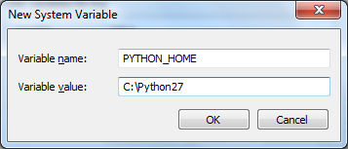

1. Add “**%PYTHON_HOME%;**” and “**%PYTHON_HOME%\Scripts;**” to your system ‘**Path’**. Ensure that there is a “**;**” at the beginning and end of the new entries in the path (unless it is the first or last entry). Refer to the screenshot below.

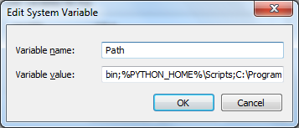

To verify if Python is correctly installed on your machine, run the below command in a command (cmd) window.

Python --version

If you get the response as shown in the snapshot below, it means Python is installed in your system. (This install was for Python 2.7.5.)

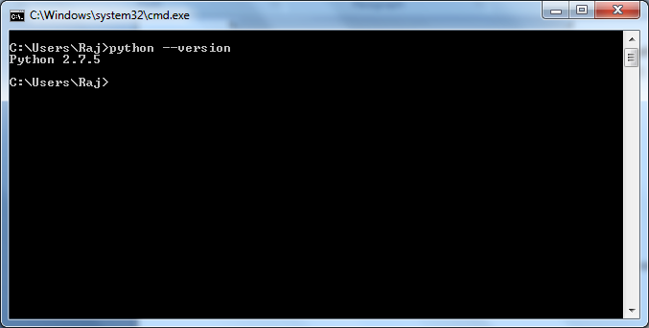

**2) Installation of wxpython**

### Link: <https://code.google.com/p/log-parser/downloads/list>

Ex: wxPython2.8-win32-unicode-2.8.12.1-py27 (for 32 bit operating system)

**Download the install the above file**

3**) Robotframework installation**

Link: <https://pypi.python.org/pypi/robotframework>

Ex: robotframework-2.9.1.win32.exe (for 32 bit system)

**Download the install the above file**

After installation please verify it typing : pybot --version in the terminal

4**) For Ride installation.**

Link: <https://pypi.python.org/pypi/robotframework-ride/1.3> .

Ex: robotframework-ride-1.3.win32.exe (for 32 bit system)

**Download the install the above file**

5**) For Pywin32 Installation:**

Link : <http://sourceforge.net/projects/pywin32/files/pywin32/Build%20219/pywin32-219.win32-py2.7.exe/download>

Ex: pywin32-219.win32-py2.7.exe (for 32 bit system)

**Download the install the above file**

6) **For WMI installation:**

Link: <https://pypi.python.org/pypi/WMI/#downloads>

Ex: WMI-1.4.9.win32.exe (for 32 bit system)

**Download the install the above file**